URL: https://adityabirlahospital.com/doctors/emergency-care-doctors-in-pune
Home / Doctors / Emergency Medicine
Emergency Medicine Doctors Near You - H1
When emergencies strike, quick access to skilled emergency medicine specialists can make all the difference. Our hospital’s emergency care physicians and surgeons are available around the clock to provide immediate, expert care for life-threatening situations. Whether you’re experiencing trauma, heart attack symptoms, or sudden illness, our team is always ready to act.
Our Team of Best Liver Transplant Doctors in Pune
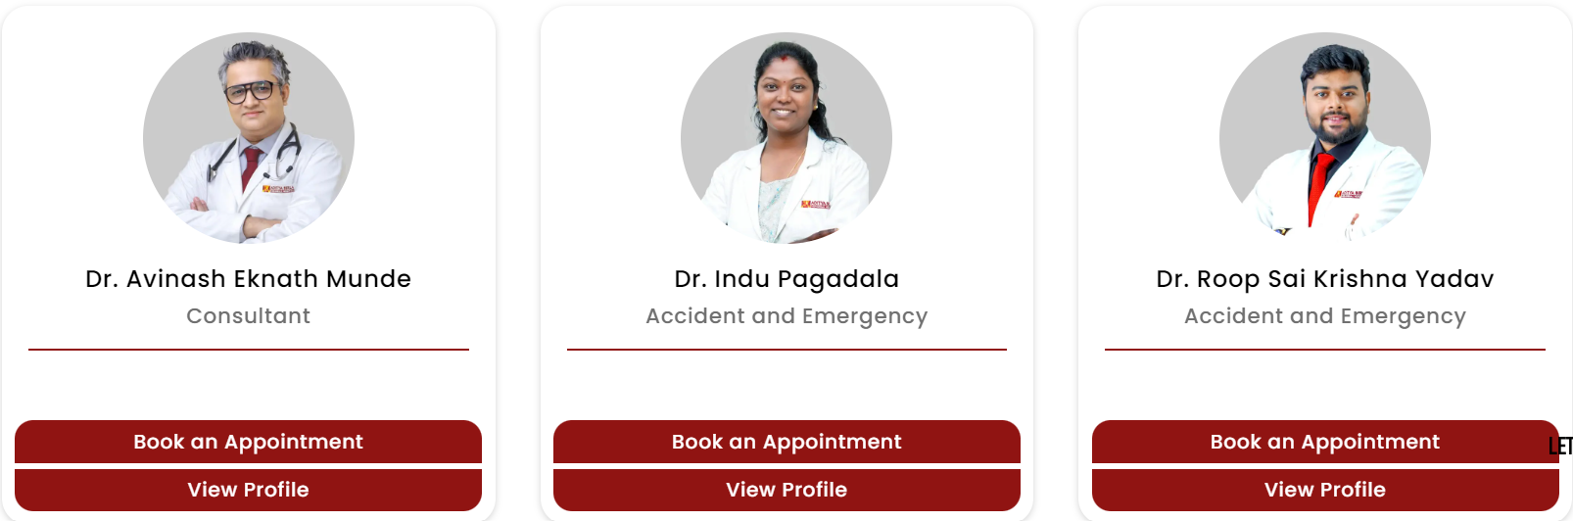
Our emergency medicine specialists in Pune are highly trained in handling a wide range of urgent medical conditions. From heart attacks and strokes to accidents and severe injuries, our emergency doctors offer comprehensive care and efficient management to stabilize patients and ensure optimal outcomes.
Conditions Treated by our Emergency Doctors:
How to Find an Emergency Medicine Doctor Near Me?
If you’re looking for an emergency medicine doctor near you in Pune, our hospital provides immediate access to emergency care. We are committed to delivering rapid care with a focus on patient safety and comfort. Our hospital’s emergency team ensures that you receive the highest level of care, no matter the time of day or night.

Nearby Locations:
Hinjewadi, Wakad, Baner, Aundh, Pimple Saudagar, Bhosari, Ravet, Chinchwad Gaon, Tathawade and Nigdi.
